Free Food Provision
Operating Food Bank Project！

What type
of project?

Due to COVID-19, Shiki City Core Welfare Counseling Center
is providing food free of charge to those with decreased
income, unable to work from the illness, and having difficulties
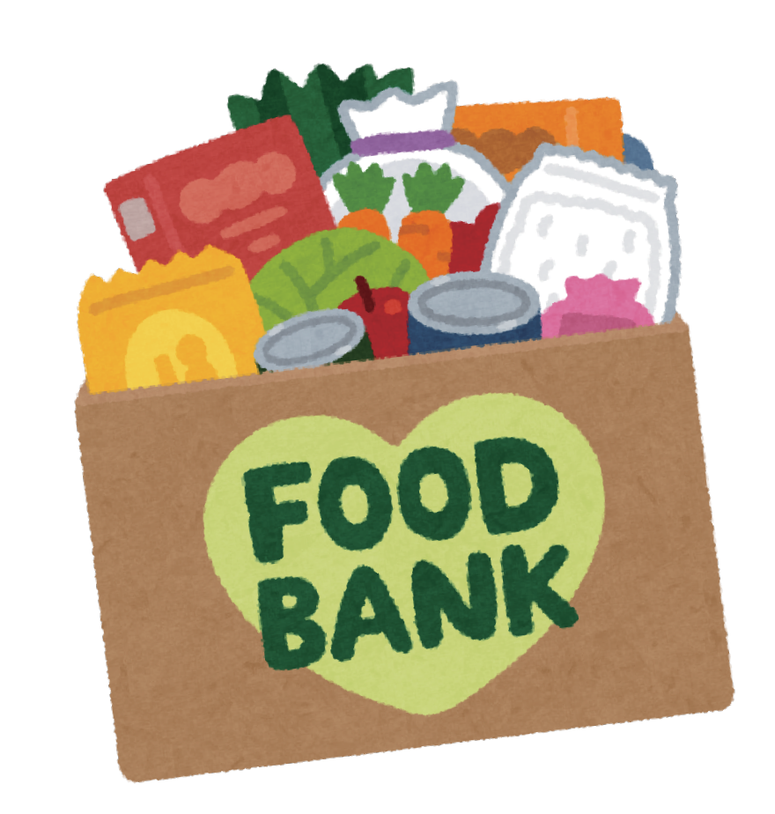
shopping for groceries.
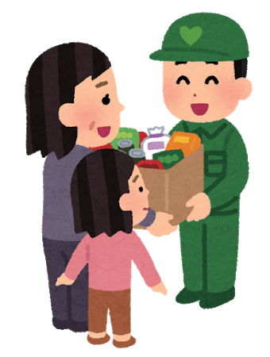

Who is eligible?

After answering questions concerning current living conditions, local Food Bank will provide food that are distributed by Saitama Food Bank and public at the counseling desk.

Free food items include rice, cup ramen(close to expiring date), retort curry, canned food and storage supplies for disaster.
Types of available food may vary depending upon inventory at the time.
★Please contact Shiki City Core Welfare Center if you wish to receive free food from the local Food Bank.

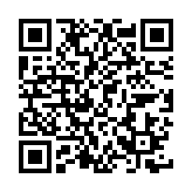
When using the Food Bank, we will ask your living conditions.
The city will provide interpreter support.
If you need interpreter, please make a reservation from QR code on the right side.
Prioritize reservations for consultation. Contact through phone or home page.
Location: Shiki City Hall No.1 Marui Family Shiki 8F Symbiotic Society Promotion Division
Shiki City Honcho 5-21-14
Reception hour: Monday ~ Friday (8:30~17:15) Closed on Holiday, Saturday, and Sunday

Consultation is free.

Phone number: 048-473-1111 (City Hall main line)
048-456-6021 (Shiki City Core Welfare Counseling Center direct line)

